**Name: Arjun Adhikari**

**Date: 17th June, 2024**

**A Third year Civil Engineering Student of Pulchowk Campus.**

**TASK-I**

**MERGING WIND SPEED DATA INTO SHAPEFILE**

I downloaded the file1.zip file from the provided link. I extracted it.

I opened the shape file in Qgis.

Initially the attribute table (in Qgis) of the shape file is :

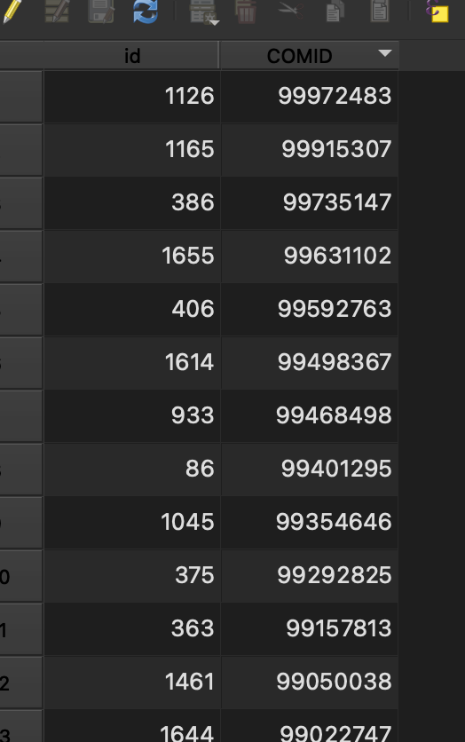

And the excel file of windspeed is:

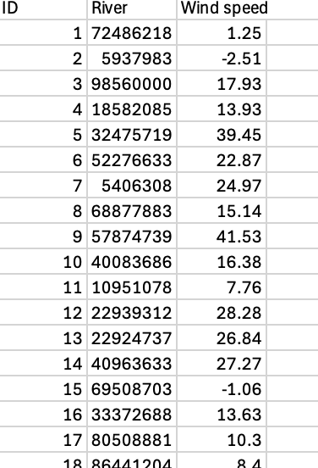

Since I have to add the data of wind speed into attribute table of shape file,

I have two options :

1. Using QGIS
2. Using python programming language.

I tried to solve using both the method.

1. **Using GIS**

Following steps were carried out:

1. Right-click on shapefile layer in the Layers panel.
2. Select "Properties" and go to the "Joins" tab.
3. And joined the layer as shown in screenshots:

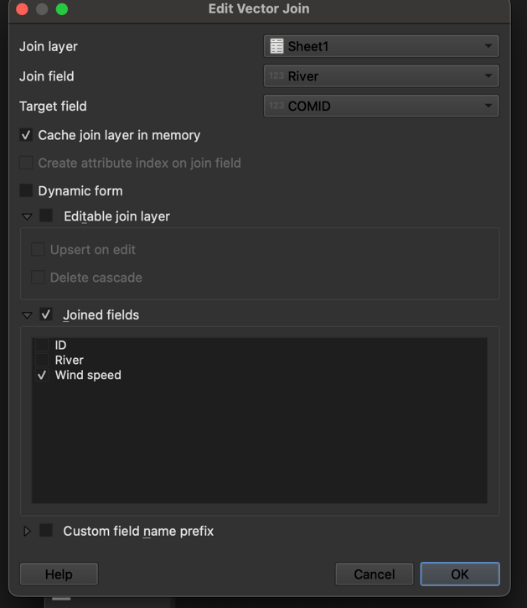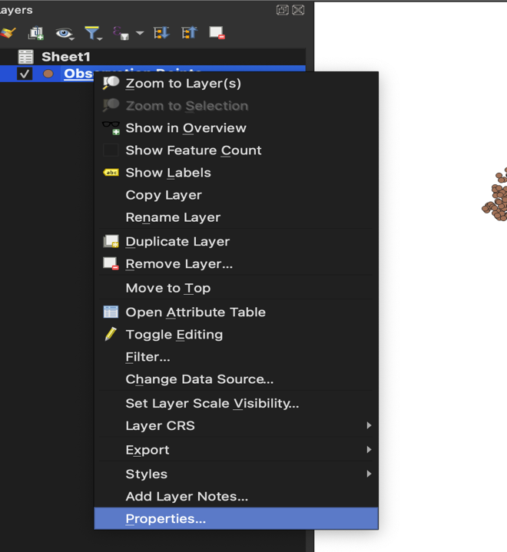

And got the desired output:

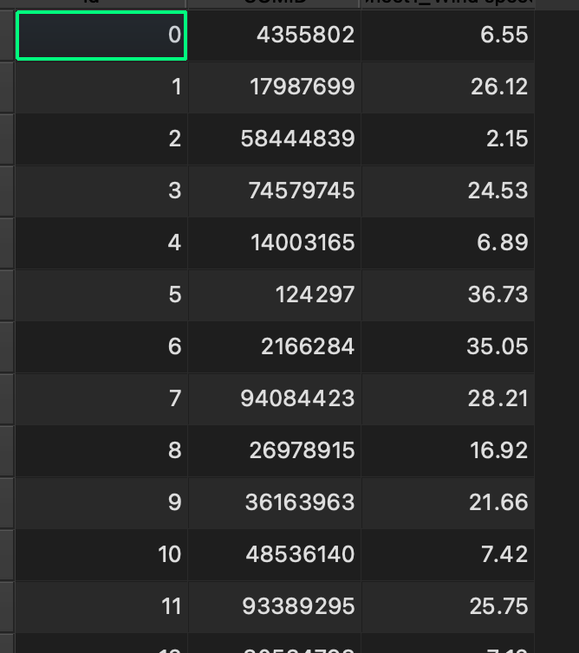

1. Using Python Programming

I opened Jupyter Notebook to begin working with the files programmatically. In the process, I loaded both the shapefile and the CSV file into Python using GeoPandas and Pandas, respectively. Upon inspecting the data, I realized that I needed to rename the river column in the CSV file in order to properly merge the wind speed data.

The solution is demonstrated in detail in task-I.pdf or .ipynb file

The final output using python is:

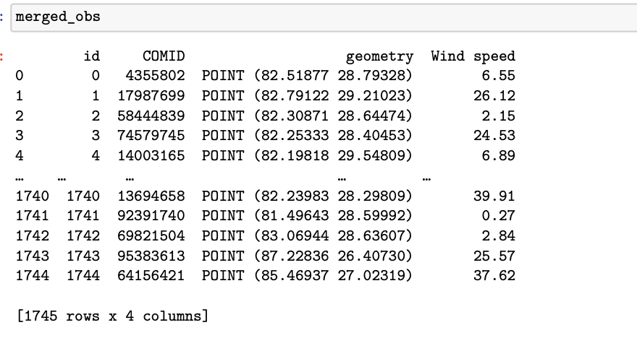

The detailed code explained step by step is in the Task I.pdf file (Jupyter notebook file)  
and the final output file is ‘Merged_Observation_Points.shp’ file attached.

**Task-2**

**Time series data for the rainfall**

I downloaded the zip file 2, extracted it, and opened the shapefile in QGIS, discovered it to be point data. I didn’t know much about Google Earth Engine, but my respected teacher, Dr. Prem Chandra Jha, had once mentioned it. While working on Task 2, I found that it was related to Google Earth Engine, which level up my interest.

I explored the documentation and was fascinated by Google Earth Engine. It became even more interesting when I realized we could import Earth Engine into a Python console. I tried to learn from the documentation and attempted to extract the data but encountered some errors. I then sought help from ChatGPT and proceeded ( the detailed step is in Task-ii.pdf )

Please verify my results.

The Area of Interest:

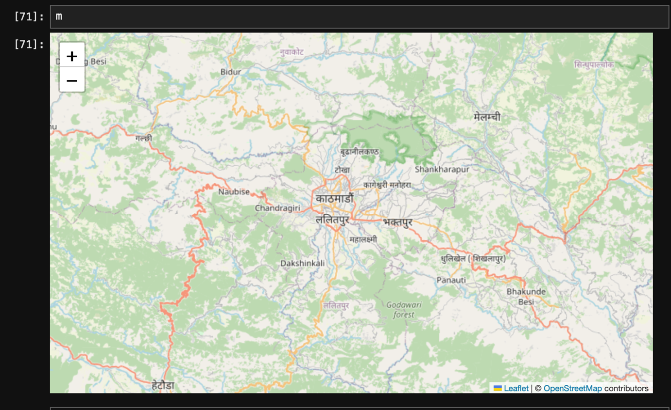

The screenshot of the final csv file is :

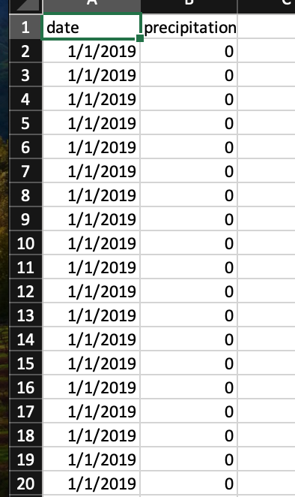

The detailed code explained step by step is in the Task ii.pdf file (Jupyter notebook file)  
and the final output file is ‘rainfalltimeseries.csv’ file attached.

**Conclusion:**

While solving these tasks, I applied my knowledge and also learned new things in the process. This tested my knowledge and enhanced my problem-solving capacity. I used my Python skills to merge wind speed data into a shapefile and to extract rainfall time series data. This dataset comprises two years of rainfall data (time series). By analyzing a larger dataset spanning multiple years, we can identify patterns, create training sets, and utilize machine learning models such as scikit-learn or Keras to forecast future rainfall.

This Word file contains only the output, while the detailed code is in task_i.pdf and task_ii.pdf, respectively.